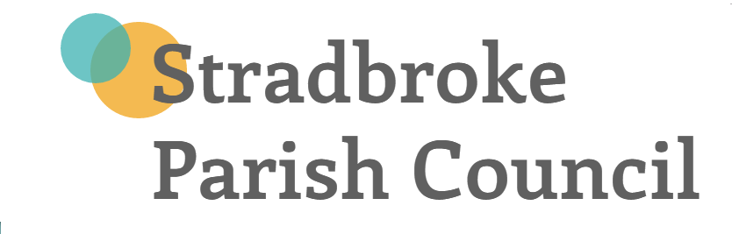

BAD DEBT POLICY

All monies owed to the Council in regards to a lease, will be collected in accordance with the terms of each individual lease. All other income will be dealt with in accordance with the guidance below.

Aims
Wherever possible, income due will be collected before or at the time of the relevant service provision or sale. Where this is not possible an invoice will be raised for immediate payment.

Values, principles & standards
This policy is underpinned by the following values, principles:
- All debts will be recorded and non-payment will be followed up by issuing reminders as outlined below
- Where a service is being provided, this will cease immediately and the debtor will be informed of this in writing and
- The service will not be reinstated until the debt is cleared and payment of future services is made in advance

Collecting debts
The following timings are intended for guidance purposes only:
- Four weeks from date of invoice – First reminder
- Six weeks from date of invoice – Second reminder
- Eight weeks from date of invoice a “final reminder” to be sent by recorded
delivery and to threaten legal action if the account is not settled within 14 days. Advice also provided that the debtor may request payment by instalments.
- After a further 14 days, where a debt is still outstanding with no agreement to pay in
instalments completed, collection of the debt to be referred to a debt collection
agency or a Solicitor.

Writing-off debts
If, after every effort has been made to collect the debt and reference to a debt collection agency is considered impractical, due to the amount outstanding, then writing off of individual bad debts may be considered.

Responsibility
The Principal Officer is responsible for the implementation of this policy.

To be reviewed in conjunction with Financial Regulations May 2017

